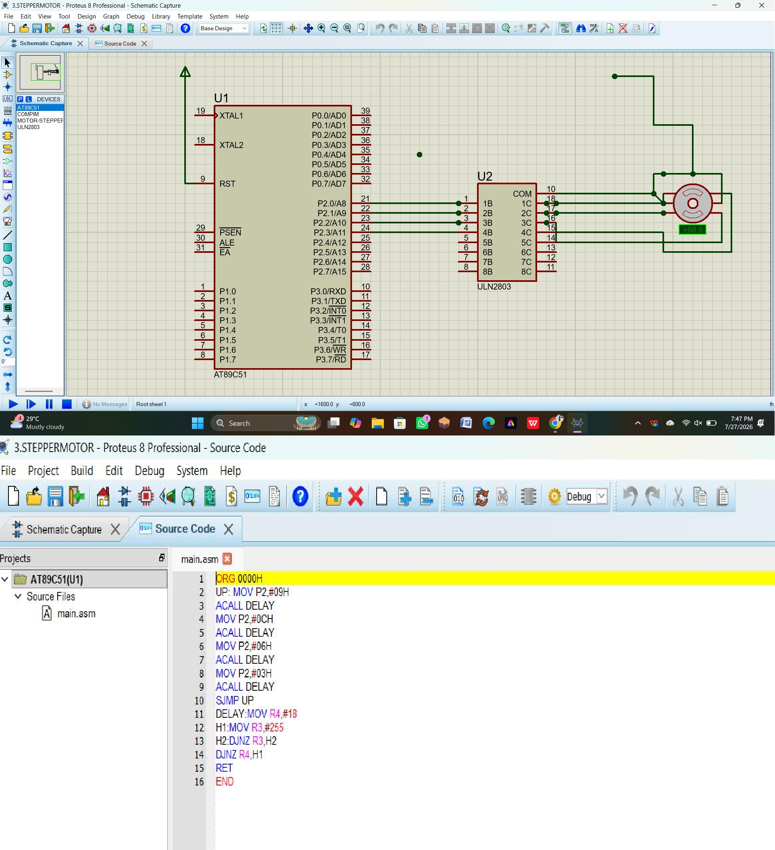
Experiment 3:Stepper Motor Using AT89C51 using Proteus DATE: 28/07/2026

